Dbt snowflake assesments

Set up snowflake

Install dbt in our local (vscode)

We have given **4 JSON datasets**:

1. **Landing**: Data about each plane landing
2. **Weather**: Temperature data recorded every 5 minutes at airports
3. **Pilot**: Pilot details (can change over time)
4. **Airport**: Airport details (can change, but we only care about the latest)

**Business requirements**

**------------------------------**

| **Dataset** | **Type** | **Requirement** |
| --- | --- | --- |
| **Landing** | Transactional | Immutable, keep all events |
| **Weather** | Transactional | Immutable, keep all events |
| **Pilot** | Dimensional | Maintain **history** when **name or grade changes** |
| **Airport** | Dimensional | Keep **only latest** version |

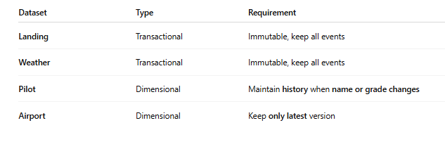

Create snowflake account

Install dbt in vscode

Created a virtual env and activate it

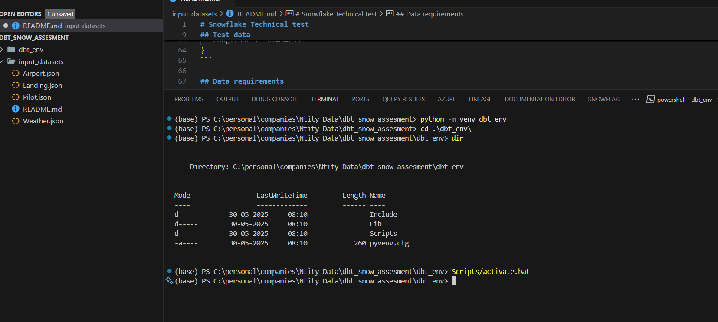

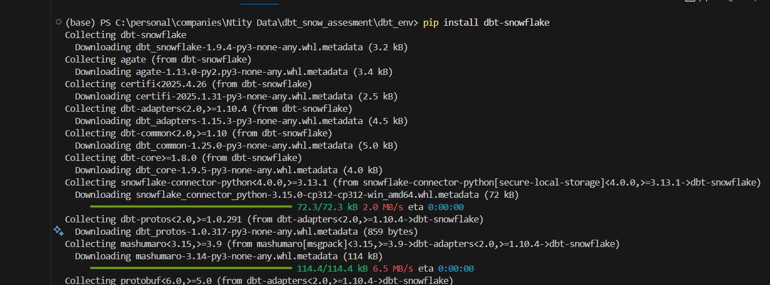

Initialize dbt snow project

* dbt init snowflake_interview_project

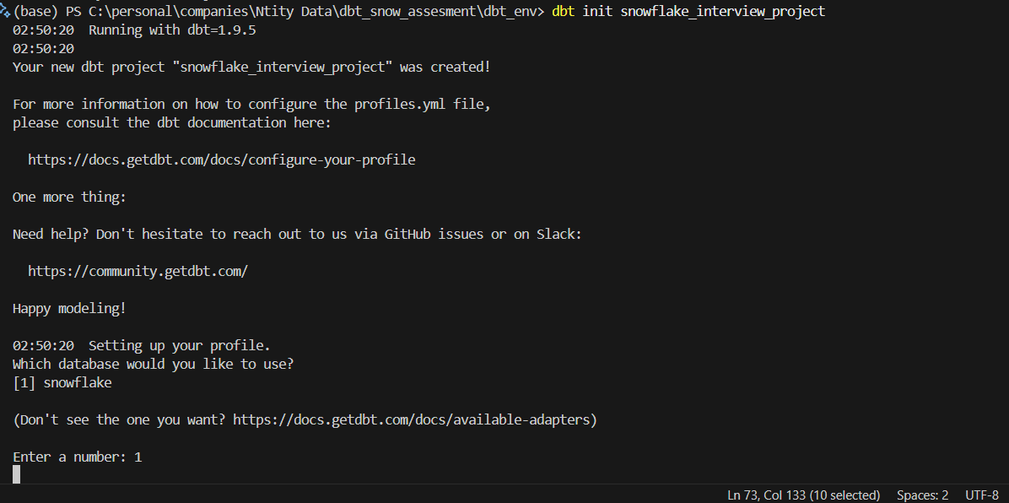

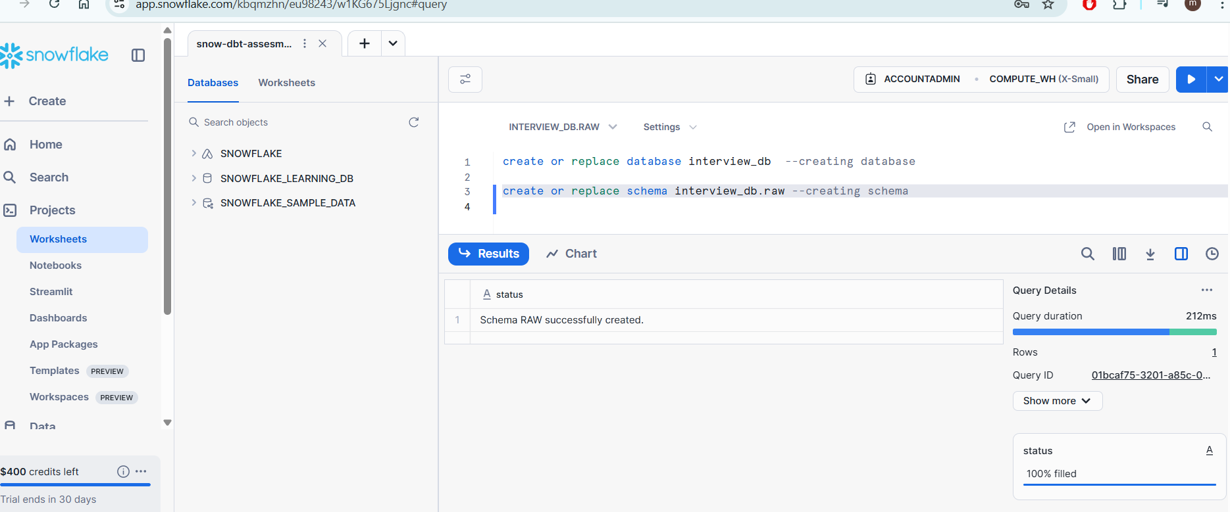

And then enter valid databse and schema name

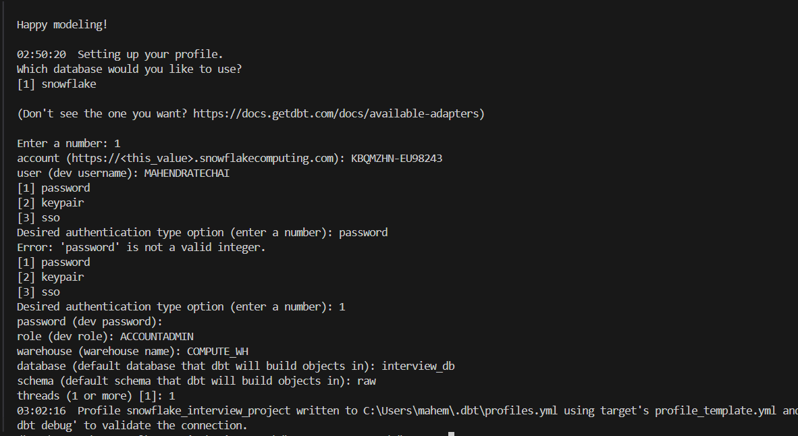

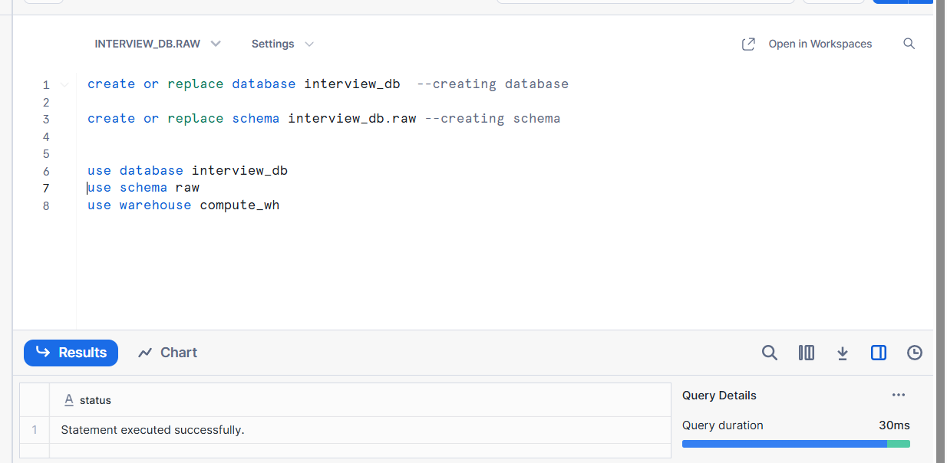

Copied input json files to data folder

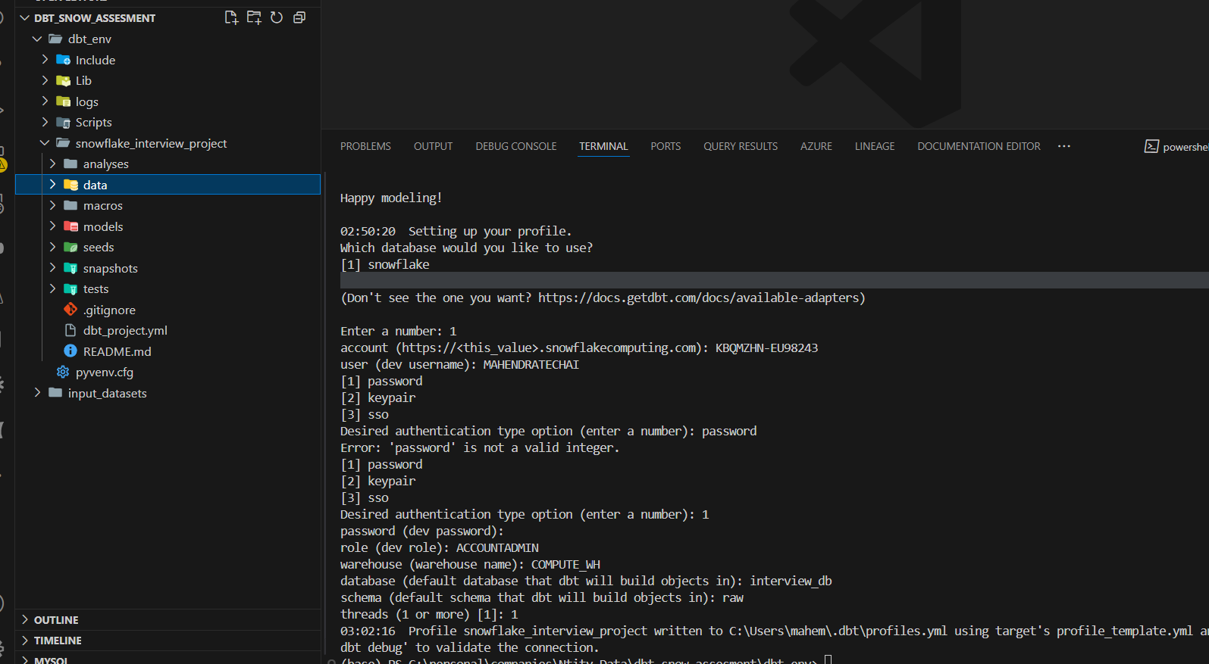

Creating raw tables in snowflake for the above data

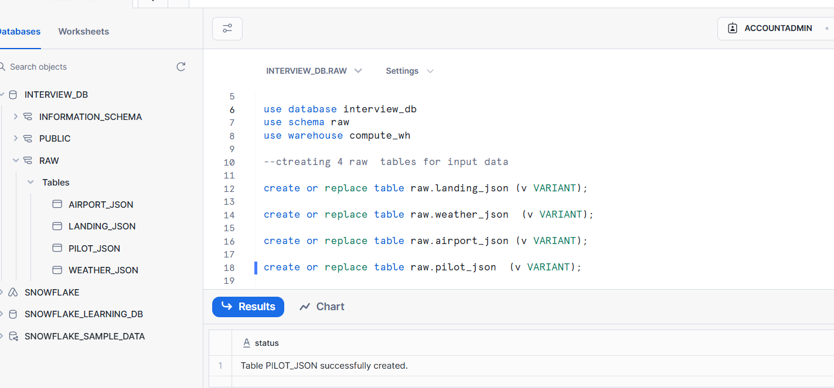

#loading the data into the tables

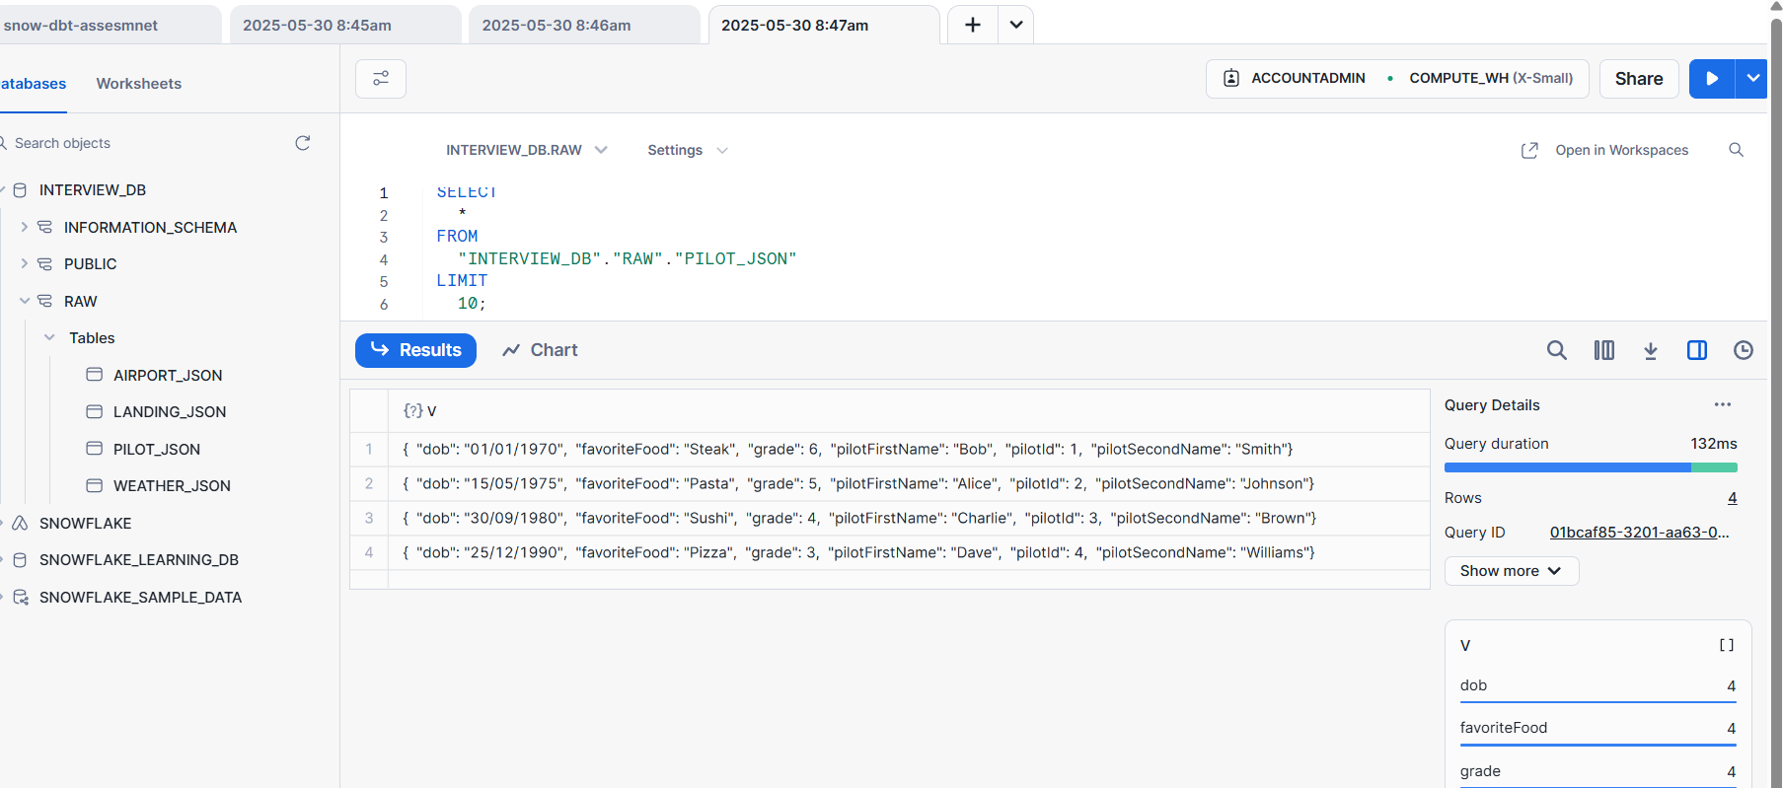

Test:

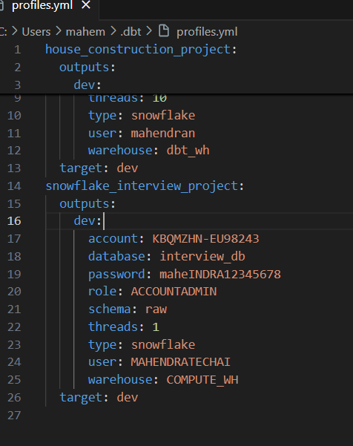

Created models for all the 4 tables and try to run with dbt run

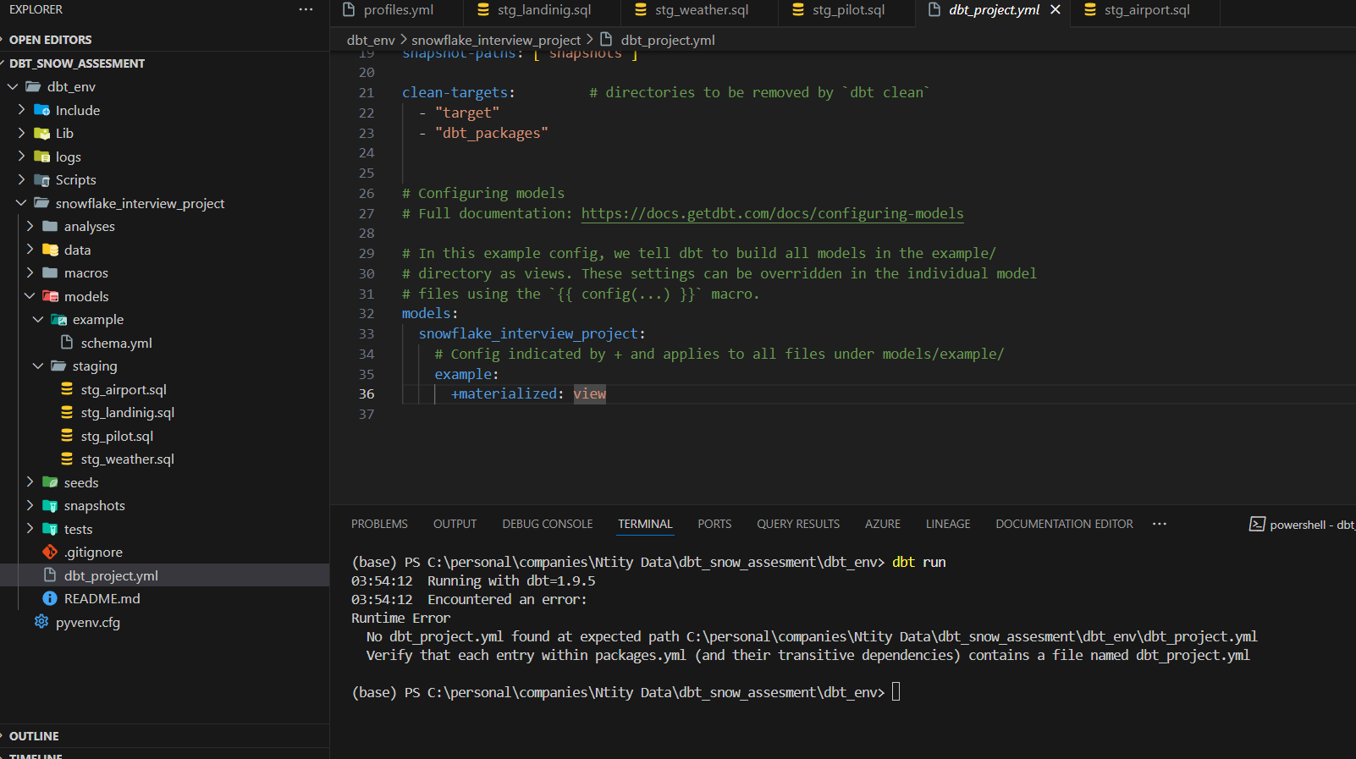

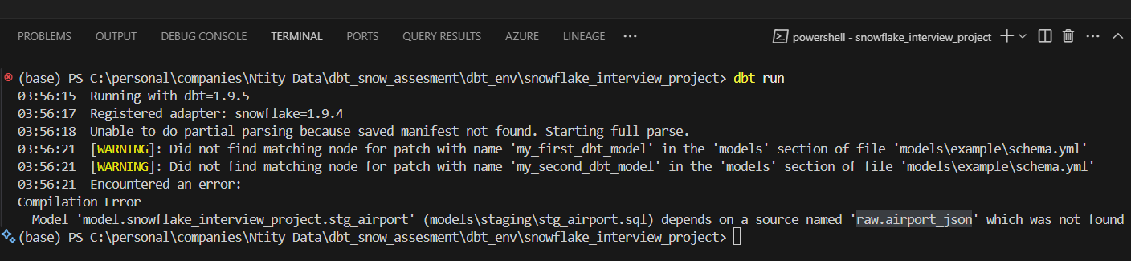

Need to add models in schema.yaml to clear this error

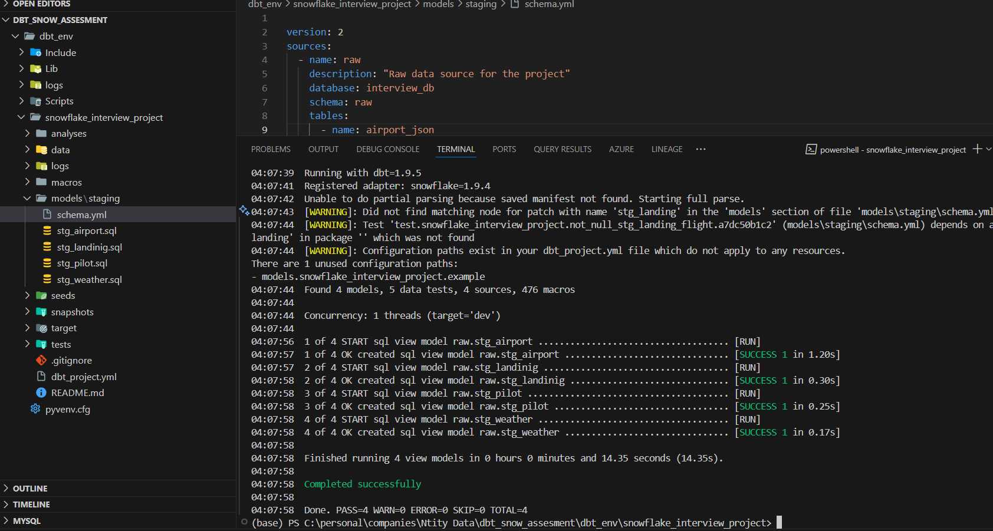

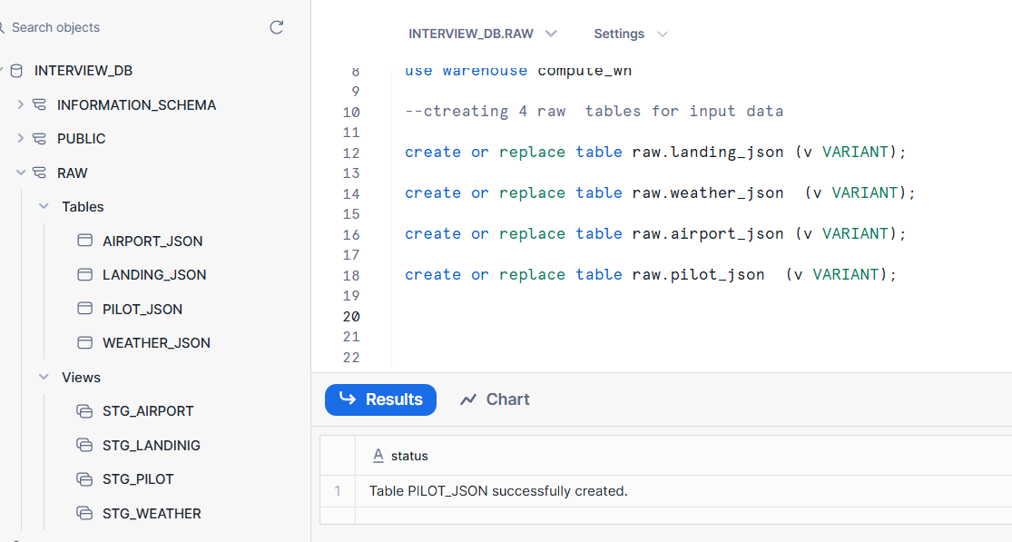

We will create an intermediate layer (models) process(transformation)

* We do join stg_landing with the **latest weather** for that airport at/before touchdown time

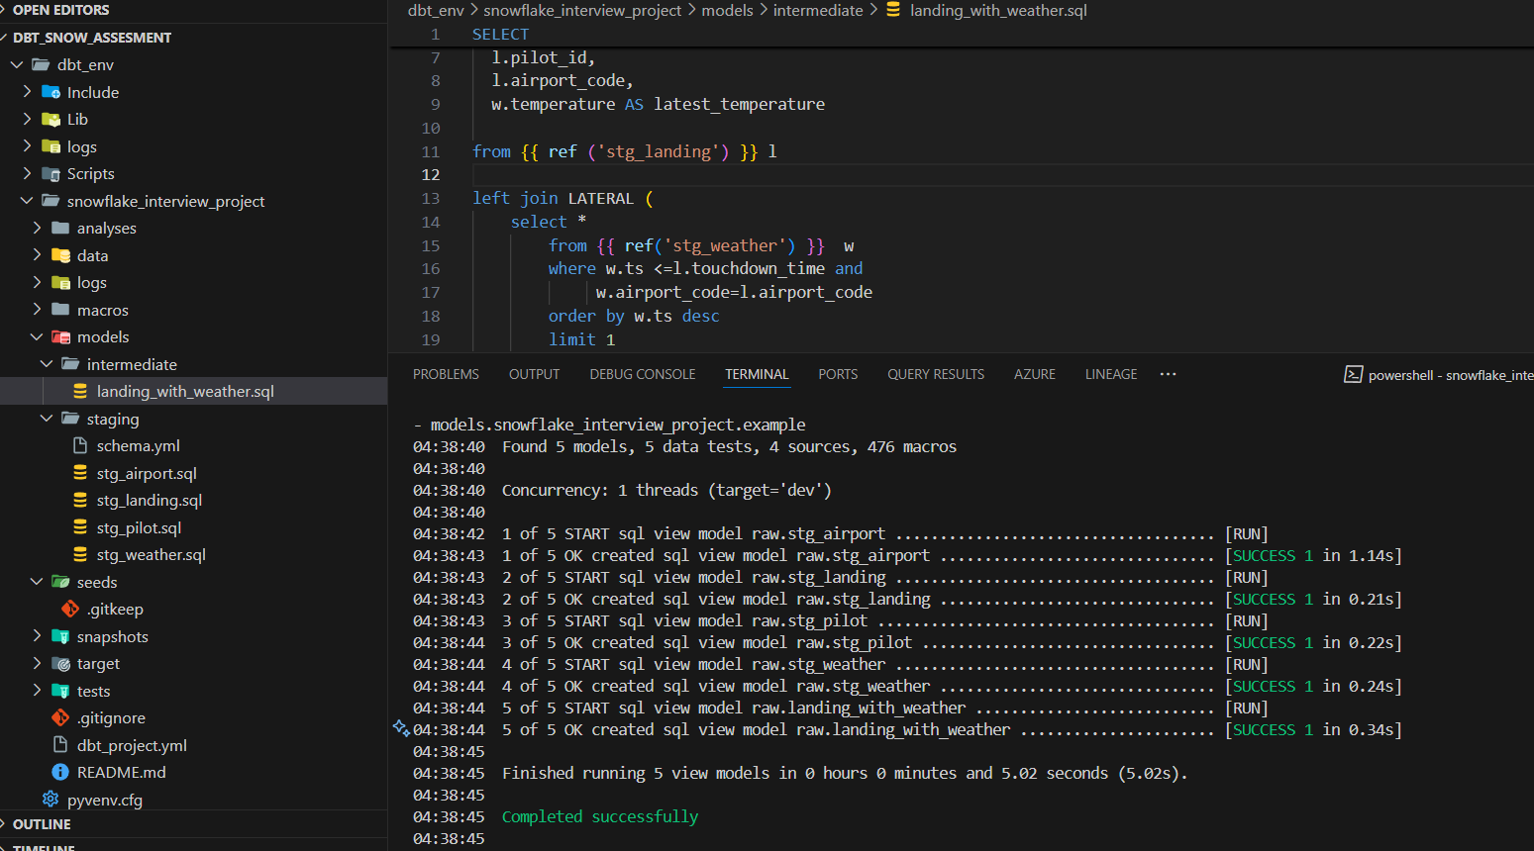

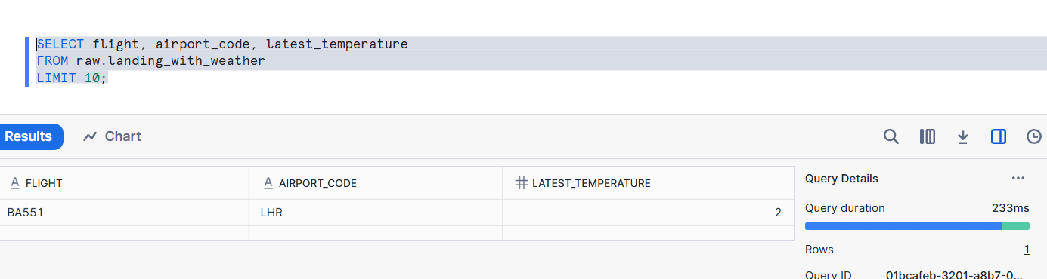

Pilot_snapshot

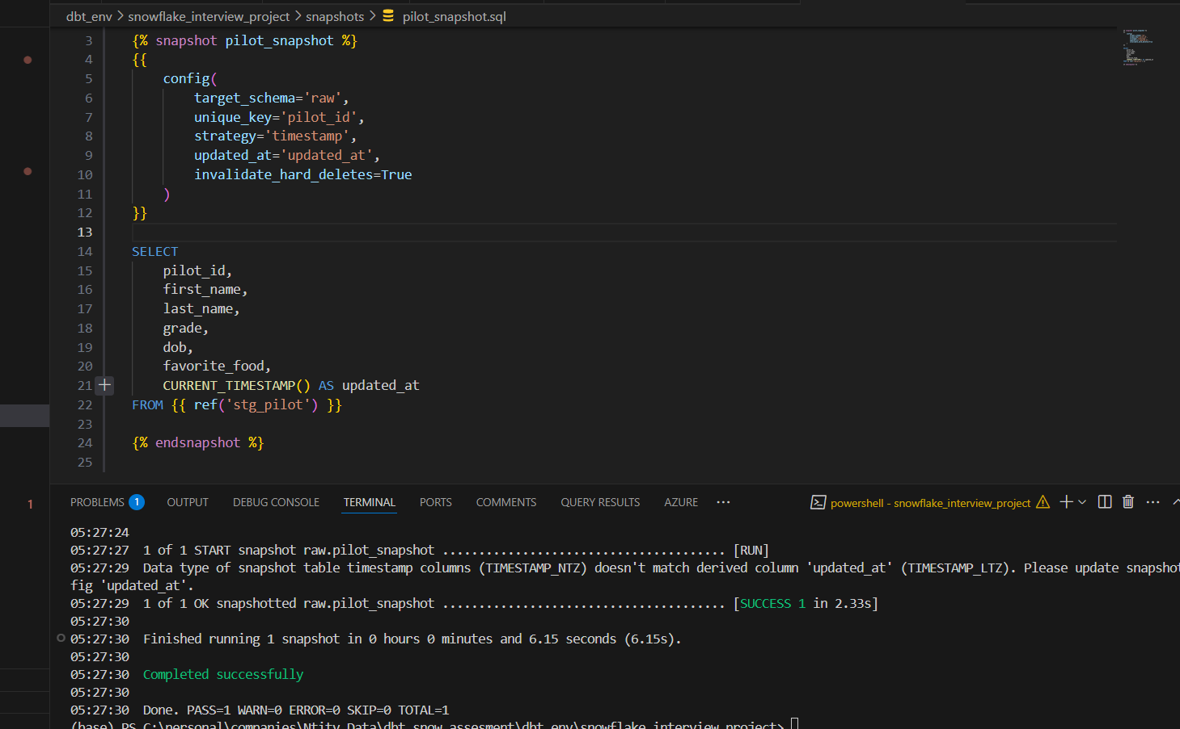

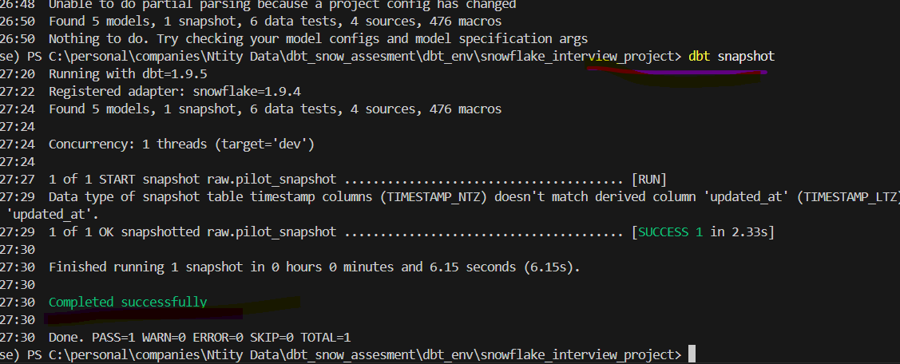

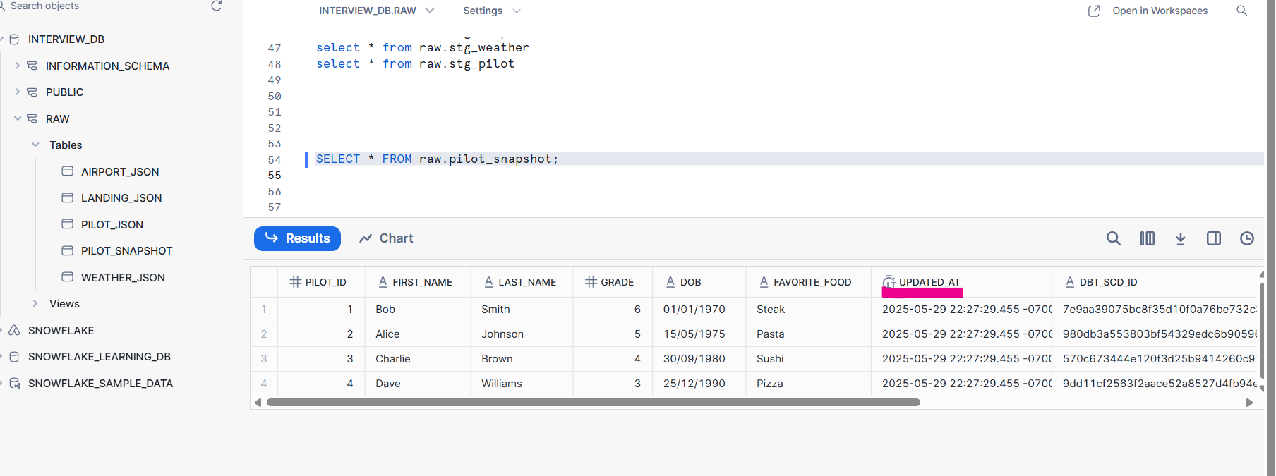

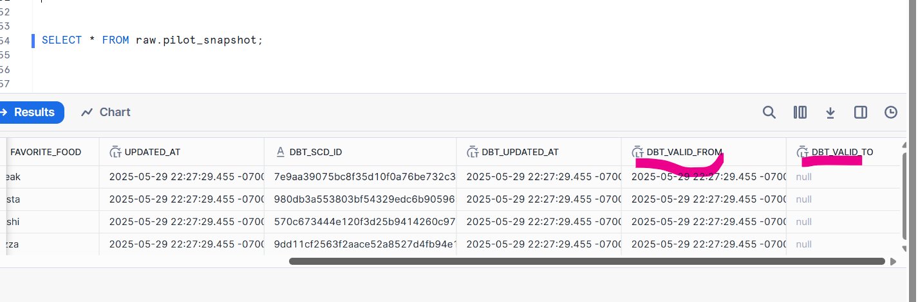

models/

└── staging/

└── stg_*.sql

└── intermediate/

└── landing_with_weather.sql

└── marts/

├── final_unmasked_landing.sql

└── final_masked_landing.sql

snapshots/

└── pilot_snapshot.sql

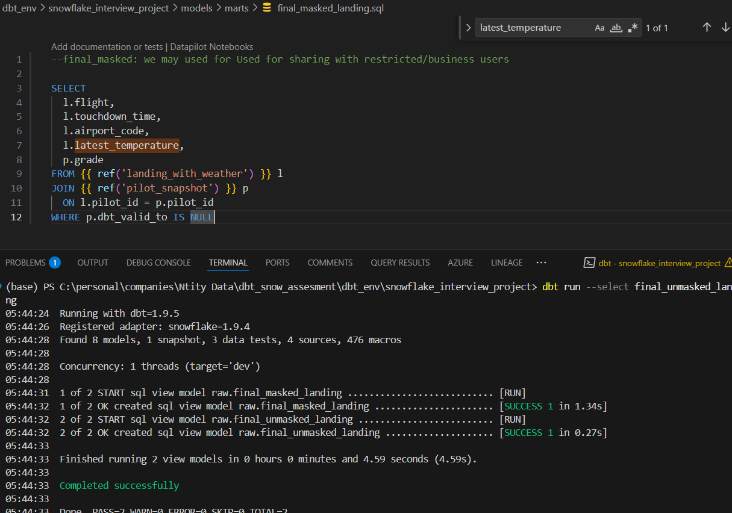

For masked landing

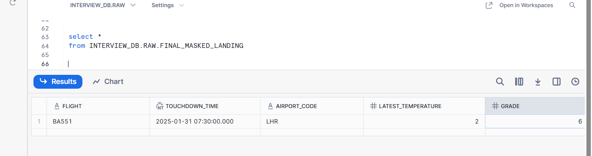

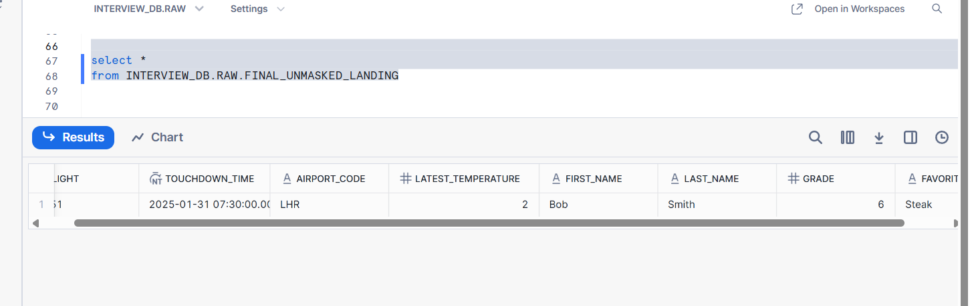

Unmasked flight(include firstname ,lastname etc …sensitive data)

